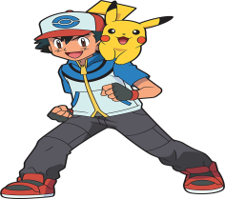
SUPERKID WORKOUT
Complete each activity, have a grown up check you off “I DID IT” and tally up your points!!!
ACTIVITY | WHAT DO I DO? | POINTS | I DID IT!!!!
Incredible Edibles | Eat some fruit for snack | 50
Chore of the Day | Pick up your laundry | 50
Exercise of the Day | 100 Push Ups  Do not have to do them all at once!!!! | 100
Brainbuster | Read for 20 minutes | 100
Log On!!  Video activity time | K-2:  https://www.youtube.com/watch?v=t6PmB6tMBOc  3-5:  https://www.youtube.com/watch?v=SdLyPaB8P10 | 150
Game Time | Play a board game with sibling or parent | 100
I’m a Superkid | Sing a song to an adult | 50
TOTAL:

