Fitness Calendar
Below is a fun fitness calendar you can do with your family. You can place the date in the upper left corner of the chart. Have fun!

Monday | Tuesday | Wednesday | Thursday | Friday
Jog in place for one minute | Do 20 jumping jacks | 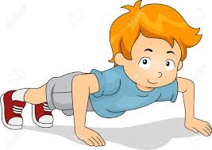  Do 10 push ups | Jump rope or jump over a line 10 times. | Do 10 sit ups
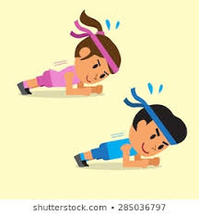Do a plank for 20 seconds. | 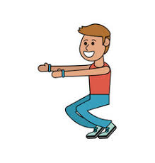  Do 10 squats | 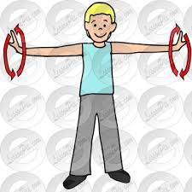Do 20 arm circles forward then backward. | 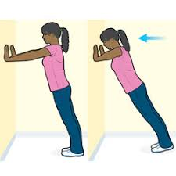  Do 20 wall push ups | Skip for one minute.
Say your ABC’s while jumping | Jog in place for 20 seconds in every room in your home. | Dance to your favorite song | Balance on one foot while you count to 10. Now balance on the other foot! | Pretend to hula hoop while saying the alphabet (use a hula hoop if you have one)
Monday | Tuesday | Wednesday | Thursday | Friday

